**Q1 (a)**

**Output:**

**Four force quantities and condition numbers:**

n max_force min_force abs_dia abs_tophori cond_num

2 731.11 -516.98 731.11 648.15 17.31

4 840.00 -885.00 708.52 840.00 40.28

8 1402.68 -1393.18 702.18 1402.68 90.71

16 2468.48 -2428.38 702.54 2468.48 267.93

**n=4:**

**spy(A)**

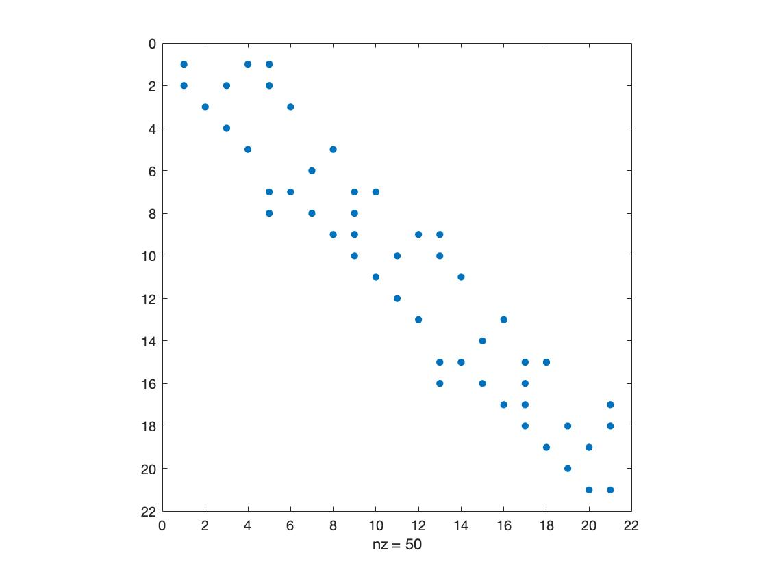

**spy(L)**

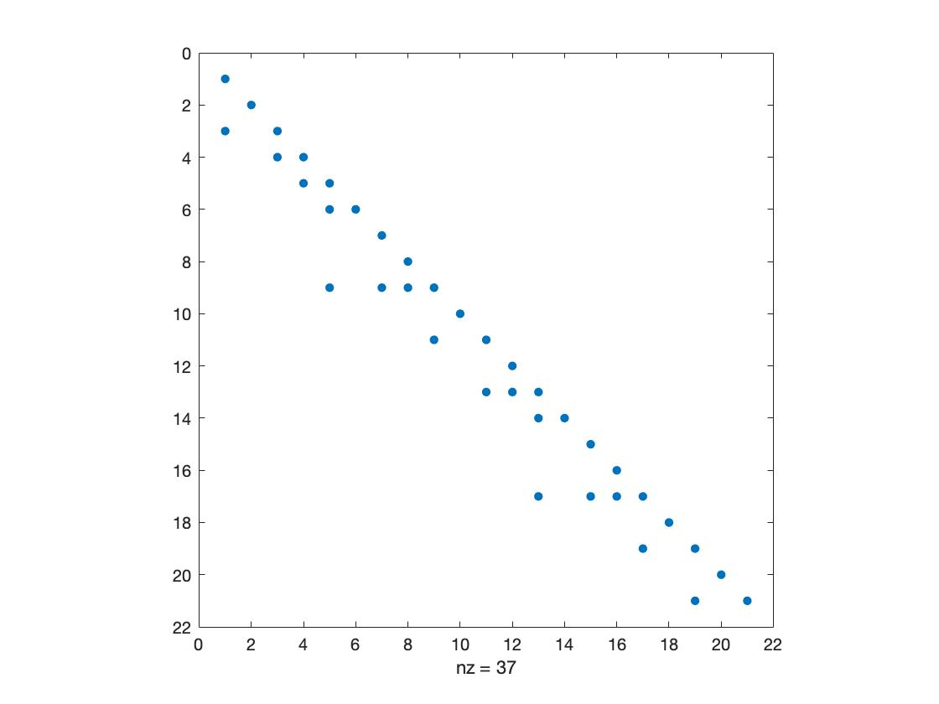

**spy(U)**

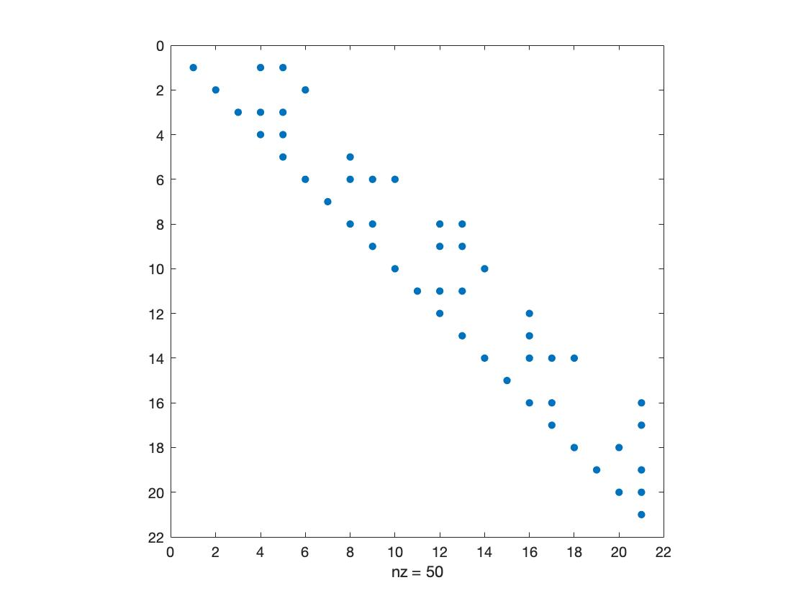

**spy(P)**

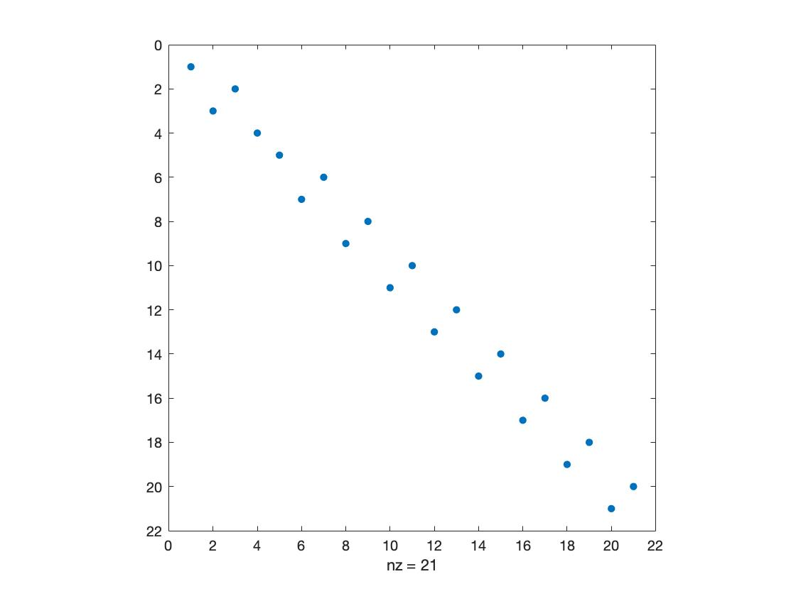

**n=16 plot:**

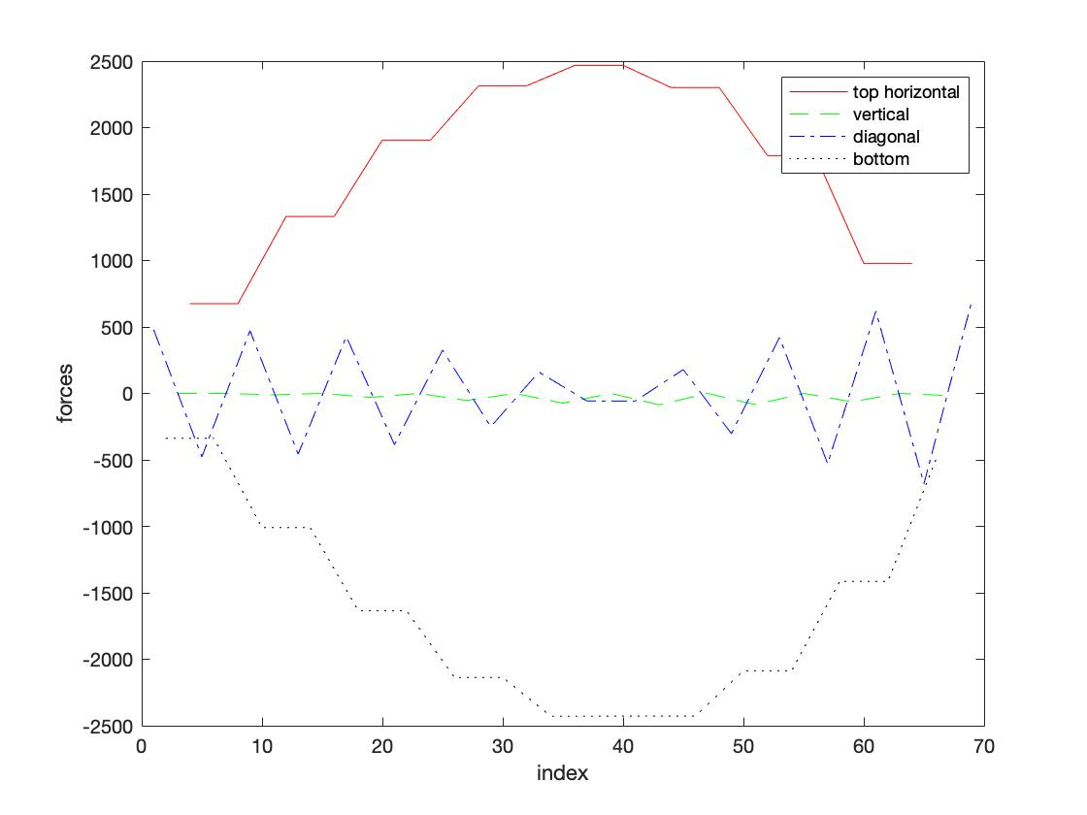

**Top horizontal members’ forces:**

